Test Case: runTestMultipleTimes
Step 1 - Enter username and password and click to button Enter : Credentials Entered
Image file-name: QC_Testing-runTestMultipleTimes-nov. 20 2025, 02 19 09 p. m.

Image file-name: QC_Testing-runTestMultipleTimes-nov. 20 2025, 02 19 10 p. m.

Step 2 - Select to UEN and Access to Administrador Roles Menu: UEN Correctly selected and Correct access
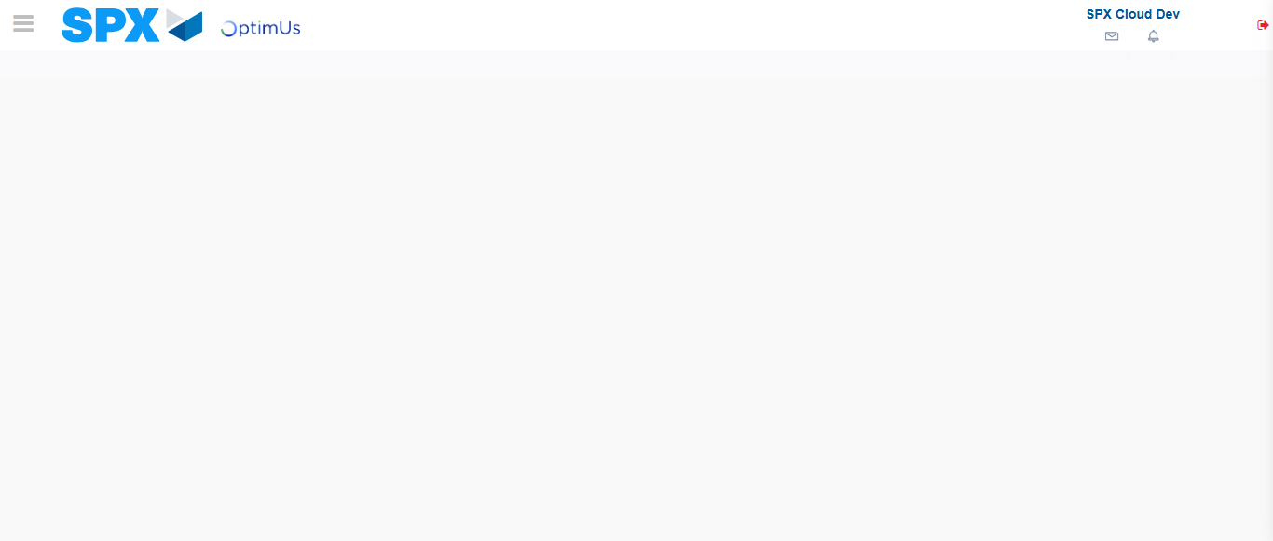Image file-name: QC_Testing-runTestMultipleTimes-nov. 20 2025, 02 19 12 p. m.

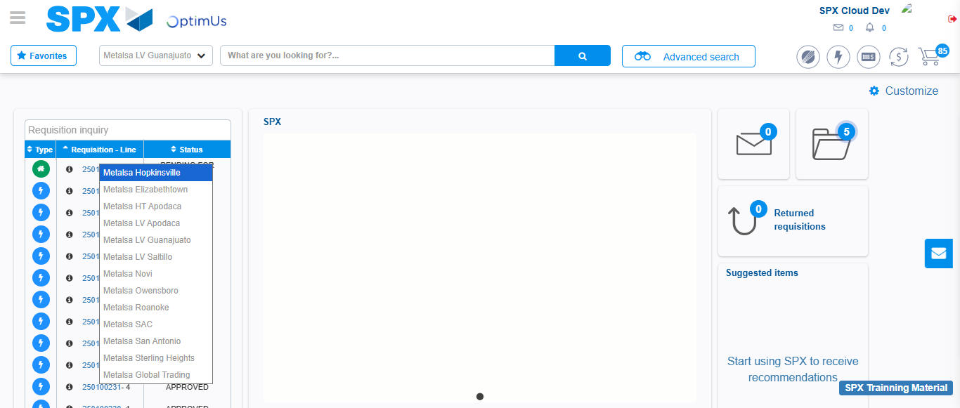Image file-name: QC_Testing-runTestMultipleTimes-nov. 20 2025, 02 19 13 p. m.

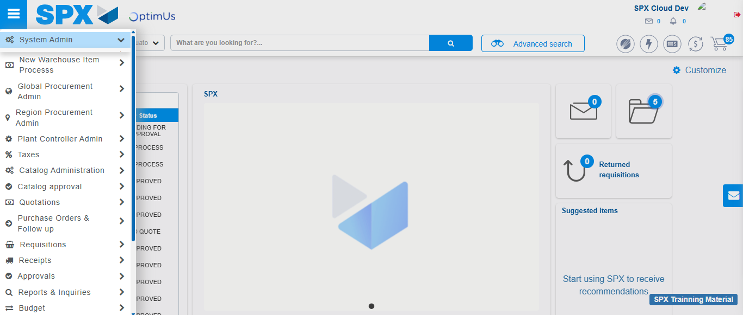Image file-name: QC_Testing-runTestMultipleTimes-nov. 20 2025, 02 19 14 p. m.

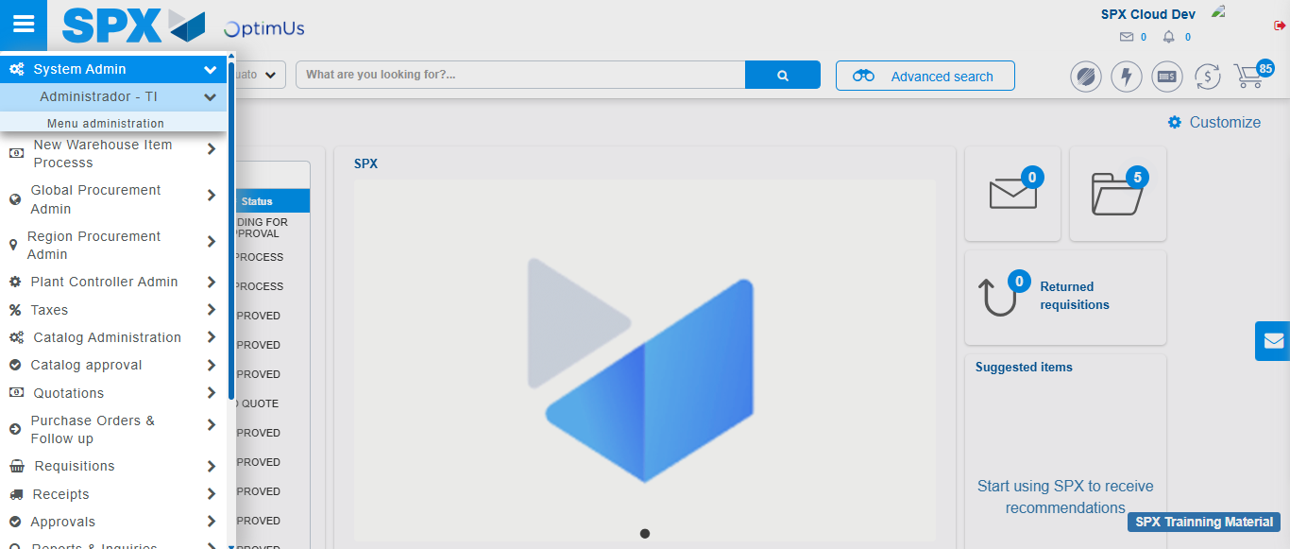Image file-name: QC_Testing-runTestMultipleTimes-nov. 20 2025, 02 19 15 p. m.

Image file-name: QC_Testing-runTestMultipleTimes-nov. 20 2025, 02 19 16 p. m.

Step 3 - Click to Buttons View Menu and Search Filter with Menu Name: Correct Search
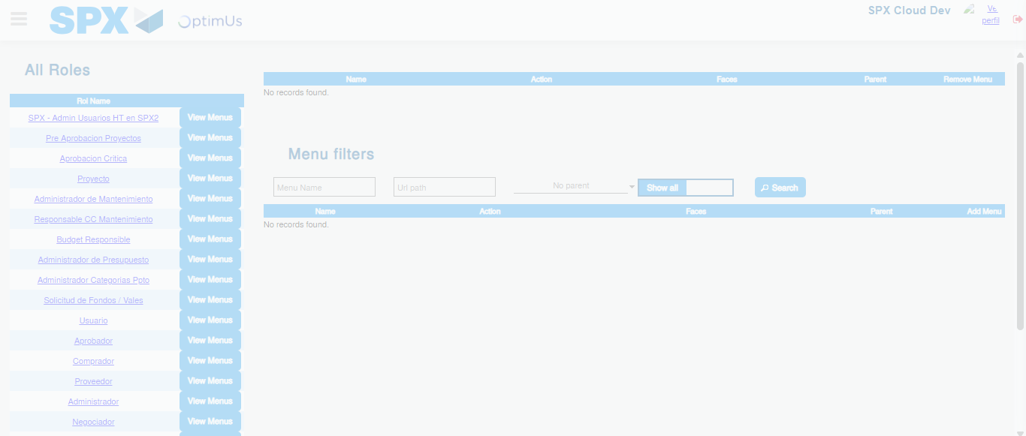Image file-name: QC_Testing-runTestMultipleTimes-nov. 20 2025, 02 19 17 p. m.

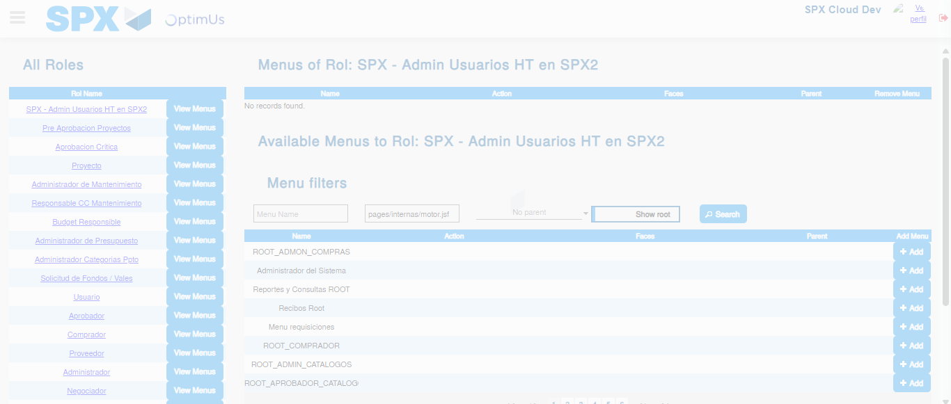Image file-name: QC_Testing-runTestMultipleTimes-nov. 20 2025, 02 19 18 p. m.

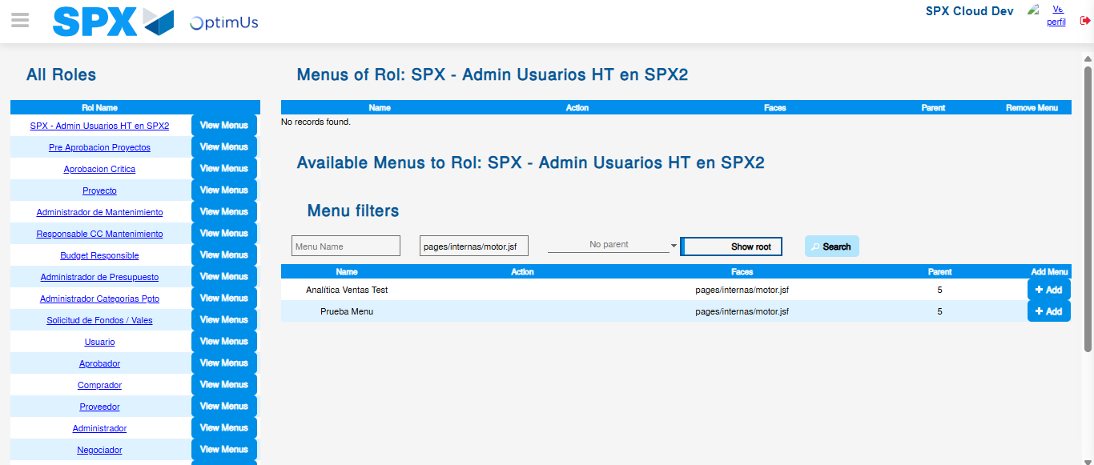Image file-name: QC_Testing-runTestMultipleTimes-nov. 20 2025, 02 19 19 p. m.

